SECTION 01

6.0 PREVOST OIL AND FILTER CHANGE

Preface. There is a general impression that maintaining a Prevost conversion is highly technical and thus should be performed only by trained technicians. While it is true there are certain things that should be left to professionals an owner that wishes to maintain a Prevost will find it is not difficult. It does require some tools, agility, and a willingness to get dirty, but in the end it is very satisfying, and will build confidence in the coach.

There are many jobs an owner can perform on a Prevost, but since few owners have the facility or tools to do the larger jobs, this paper will cover routine preventative maintenance, primarily those tasks that need to be done regularly.

It needs to be noted that these instructions and recommendations apply to my 1987 40 foot XL and my current 1997 45 foot XL. If the Prevost or engine manuals have information that differs from what I wrote their instructions are to prevail. Your coach may be different from the one shown in the photos. Your converter and installed equipment may make some of the remarks incorrect or incomplete.

Any time you go under your coach I urge you or your technician to support it with jacks or jack stands. Chock the wheels, and never trust the air bags to not fail.

6.1 Tools required

For an oil change you will need the following tools:

Drain pan capable of holding at least 10 gallons
Large filter wrench (I suggest the type shown in the photo)
Hammer and punch (to drain the filters)
Wrench (a Series 60 requires a 1 1/6 box or open end wrench)
White grease

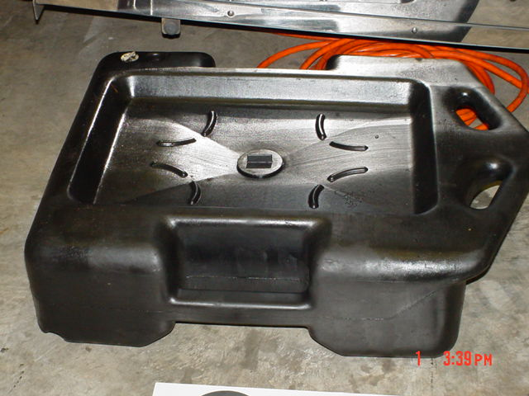
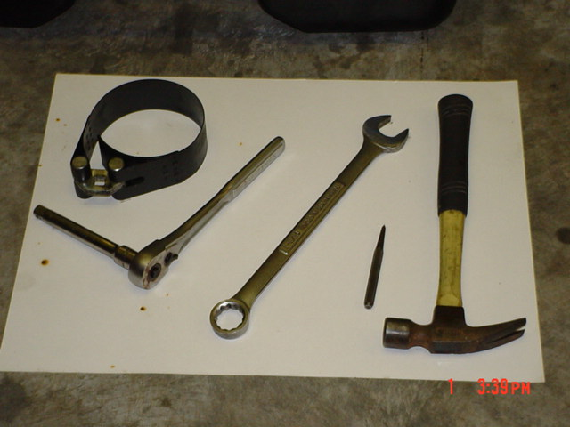

6.2 Oil removal

I have changed my engine oil every 5,000 miles. That is more frequent than the interval suggested by Detroit Diesel or Prevost, but I view the irregular, infrequent coach use (compared to commercial service) as harsh service. Whatever change interval you determine is best, the oil change should include replacement of the engine oil filter(s). An 8V92 has one and a Series 60 has two filters, located on the driver’s side of the engine in both cases.

To prepare for an oil change raise the rear (only) of the coach to its full height. Place bottle jacks or jack stands of sufficient capacity under the Prevost rear body support points to keep the bus safely in the air while you are under it. The support points are shown in the Prevost owner’s manual.

While some may prefer to drain engine oil when it is up to operating temperature, and will flow freely I would rather change it after the coach has cooled down at least over night. This is your choice, but I would caution you to be very careful if you change hot engine oil.

Position the drain pan under the filter(s). (NOTE: PRIOR TO PUNCHING A HOLE IN THE FILTER IT IS SUGGESTED YOU LOOSEN IT ¼ TURN. IF YOU PUNCH A HOLE IN THE FILTER AND FIND YOURSELF INCAPABLE OF REMOVING IT YOU WILL NOT BE ABLE TO DRIVE THE COACH FOR REMOVAL OF THE FILTER.) These hold a considerable amount of oil so I use the hammer and punch to make a hole in the bottom of the filter(s) and allow it to drain for a while Using the filter wrench remove the filter(s). Usually when the filter is loosened and the seal is broken additional oil will flow from around the filter gasket and from the hole punched in the bottom.

After the filter(s) have been removed reposition the drain pan and remove the engine crankscase drain plug. Once the plug is loosened with the wrench it can be removed using your fingers, but be aware there will be seven or more gallons of black, dirty engine oil spewing from the drain hole once the plug is removed. It will come out with such force it will flow almost horizontally before the flow abates and it starts flowing and dripping down into the pan. Anticipate that gush of oil when positioning the drain pan and your hands.

While the oil is draining examine the drain plug. It is expected to have oil on it but it may also have some fine iron or steel pieces because the drain plugs are generally magnetized. It is not uncommon to have minor or negligible amounts of steel or iron particles, but large amounts or large pieces are cause for concern. If you do find what you consider to be an excessive amount of iron or steel shavings or particles I suggest you take the removed filters to a Detroit Diesel dealer or reputable large engine repair facility so the filters can be cut open and examined. A trained technician can then either give you peace of mind that your engine is OK or that it may have issues that need further attention.

Replace the drain plug after the engine is drained, and clean the oil filter gasket contact surfaces on the engine. Lightly coat the filter(s) rubber gasket with white grease lubricant. If you have no lubricant, engine oil will work, but I prefer white grease.

Fill the filter(s) with engine oil (this is important) and thread the filter(s) in place by hand. As soon as contact between the rubber gasket and the gasket surface is made (you will feel the filter spin less freely), rotate the filter another ¾ of a turn. Do not over tighten. You should not have to use the filter wrench to tighten it.

As long as you are under the coach this is a perfect time to do other things like examining the underside for leaks, changing fuel filters, changing coolant conditioning filter(s) and cleaning the engine and surrounding area with a suitable solvent.

6.3 Replacing engine oil

The type and quantity of the oil you use is dependent on the engine. Refer to the Prevost owner’s manual for this information. The 2 cycle engines require 40 weight, and the Series 60 requires 15W40. Both oils must meet the Detroit Diesel specifications.

Drain the oil reservoir into the engine. I do this so I have fresh oil in the reservoir, rather than oil that has been in there for a long time. Add sufficient new oil to fill the oil to the full mark on the engine dipstick. Close the reservoir valve and refill the reservoir. If you are finished with all of your work under the coach, remove the jacks or jack stands and make sure the coach leveling system is set in the road position. Start the coach up from the driver’s seat and check for oil pressure. Because you drained the oil it may take a short time interval for pressure to come up to normal.

With the coach running go to the rear and look carefully for any leaks or drips from the filter(s) or the drain plug. If none are found, shut the engine off and after a reasonable period of time, check the oil dipstick for proper engine oil level. Give sufficient time for the oil to return to the crankcase. Add some if necessary.

Dispose of the used engine oil and filters properly.

6.4 Summary

A few comments are necessary. It is fairly important to clean your engine and keep it clean. Apart from making an oil change more pleasant, a clean engine allows you to more easily see and track leaks. Also, do not over fill the crankcase. I keep rags or absorbent material available to clean up spills or drips. It is hard to change oil or filters without dripping.

An oil change is a perfect opportunity to look carefully for evidence of loose clamps which hold hoses or wiring in place safe from harm, it is a good opportunity to inspect hoses and clamps for leakage, and it is the only time you will be able to see the area towards the rear of the engine (towards the front of the coach) to verify your engine oil seals are not leaking and there is no physical damage to your engine oil pan or transmission oil pan.

Jon W. Wehrenberg 12/14/2005

